SUMMARY OF PROBLEM STATEMENT, DATA AND FINDINGS

1.1) PROJECT OVERVIEW:
This project has been set to focus over the sales of an e-commerce company. When it comes to e-commerce, it has been widely discussed that the sales fluctuate vastly over time. In order to keep the sales up to the level, companies adopt different strategies at different points of time to achieve the goal. One such marketing strategy is using promotional strategies. This strategy has been found beneficial for most in the e-commerce sector. Thus, this project aims to study the impact of such promotional strategies specifically for an online clothing retail company. The project aims to identify whether these promotional strategies genuinely increase revenue or only create temporary spikes in order volumes. It is a major analytical challenge how different promotions have an impact on the sales and which would be the most beneficial strategy.

1.2) BUSINESS PROBLEM STATEMENT :
1.2.1) Business Problem Understanding
It has been observed that in the e-commerce sector especially clothing retail, the revenue seems to attain a level of saturation quite faster after which there isn't a significant raise in the revenue mainly due to a reduction in number of repeat customers. This could be due to a limited product catalog, unlikely product recommendation, lack of promotional strategies etc.,
1.2.2) Business Objective
The primary and fundamental business objective is to significantly and substantially improve overall sales, revenue. Influence of promotional activities in sales and check whether it has a positive or negative impact on sales.
1.3) DATA AND FINDINGS:
To align with the objective, the dataset must contain the information about sales along with any promotions applied on the product. Also, having details of the different product categories, quantity of purchase and time period of sales have been found crucial. The dataset used in this project is 'Amazon Sale Report.csv', containing order-level transactional data from XYZ E-Commerce operating through Amazon.in. Each record represents one customer order and includes details such as order status, product information, quantity sold, price, and shipping details.
The dataset contained a total of 128,975 rows and 24 columns before performing any pre-processing methods. It has two numerical columns and 22 categorical columns. Some of the columns haven’t been contributing any useful information to the model, those columns were dropped as a part of pre-processing.
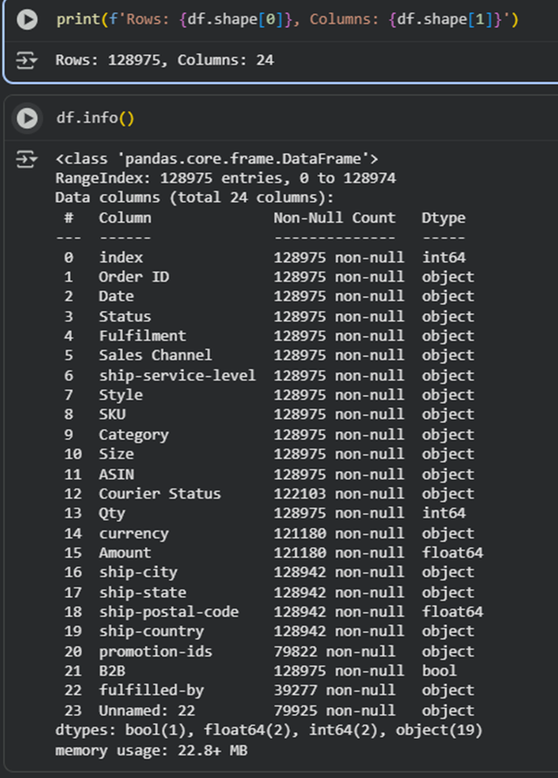
Fig 1: Columns in the dataset
To address this objective, it has been decided that prediction using machine learning can be used to derive a solution. However the dataset directly can’t be used to build a machine learning model. Thus, the dataset has been manipulated to comply with the conditions of machine learning. The machine learning technique that was found suitable for this purpose was supervised learning. To build a supervised model, presence of a target column is crucial and in this dataset, the existing columns were unsuitable for being a target. Hence a new target column “Amount_y” has been feature engineered to solve the purpose. Since, the target column being a numerical one, the model built happened to be a regression model.

- OVERVIEW OF THE FINAL PROCESS

2.1) OVERALL PROCESS

When machine learning was agreed to be the method, it involved a series of steps to follow to build a valid model. This data driven approach has been chosen because working on the previous data gives an idea of the overall sales history, a trajectory to follow, and offers the patterns and trends formed due to the earlier sales. This approach ensured fairness and took care of the logical explanations behind the decisions made as a result. This approach beginned with scouting the desired dataset, followed by data pre-processing, feature engineering, encoding, model building and ended with model validation. A detailed walkthrough of each and every process and crucial involved in those processes have been discussed in detail in the later sections of this report. The final model’s performance has been evaluated with the help of notable metrics like the explained variance score, r2 score, RMSE (root mean squared error).

2.2) DATA PRE-PROCESSING

Data pre-processing had a huge importance when building the machine learning model. Covered several areas to focus when manipulating the data. Key areas focused were identification of null / missing values and how much percentage did they cover with respect to the entire dataset. Then the columns in the dataset have been checked for anomalies. The presence of both missing values and anomalies impacts the performance of the ML model. They often tend to overfit or underfit the model and cause it to perform poorly with the test data. In the overall dataset, the presence of both null values and anomalies have been detected and treated for the improvement of model performance.

Another main pre-processing step could be the detection and treating of outliers. Outliers are very common when it comes to sales data due to varying pricing points of the products and the quantity they are being purchased in. This dataset is no exception, we have detected the outliers in the “Amount” and “Qty” columns. Treating outliers can be decided based on the application of the model. In some cases it may be ignored, in some cases including them might add more meaning. In this dataset, it has been decided to proceed with the outliers due to the fact that selling should include all corner cases since it also be accounted for while applying promotions.

2.3) FEATURE ENGINEERING:

Feature engineering is where necessary decisions like splitting of columns, scaling the data or transforming the data has been decided. In this case, the target column has been feature engineered to solve the purpose. The main purpose of feature engineering is to understand how it can be structured so that the model can learn and perform better. In some cases, feature engineering may not necessarily involve splitting of columns, but could also be renaming categories, grouping them or even replacing them.

2.4) ENCODING

Encoding is a very crucial step in building a machine learning model. This process ensures that the categorical columns have been converted into numerical columns since the model can understand only numbers. Doing so, there are several types of encoding that are being used depending on the nature of the categorical column present. In this dataset, encoding played a huge part since most of the columns are categorical. Different types of encoding like ordinal encoding, ordinal encoding, n-1 dummies etc, have been used depending on the columns and how they were classified.

- STEP-BY-STEP WALKTHROUGH OF SOLUTION

3.1) UNDERSTANDING THE DATA

The very first step of any data science project would be having a clear understanding of the dataset that is being used. The dataset has been decided after checking whether it had all the necessary information needed to address the problem statement. When it has been confirmed, the dataset has been finalized to be used.

The obtained dataset contained 128975 rows and 24 columns in total. However not all of them were adding meaning to the problem statement. It has been found that some of the columns showed a bit of inconsistency, had null values, lengthy sentences and also presence of duplicates.
These issues were addressed and resolved before proceeding to build a model.

3.1.1. Detecting Null values
Missing values were calculated using (df.isnull().sum() / df.shape[0]) * 100 and Several columns contained missing entries. Some of the columns like “fulfilled-by” had nearly 68% of missing values. So, it has been decided to drop the column as it will mislead the model. Similarly, promotion-ids also had 38% of null values which is also a significant number, but since it is an important feature for this study, it has been treated using (fillna()) with mode. The information containing null values in other columns can be found in the image below.
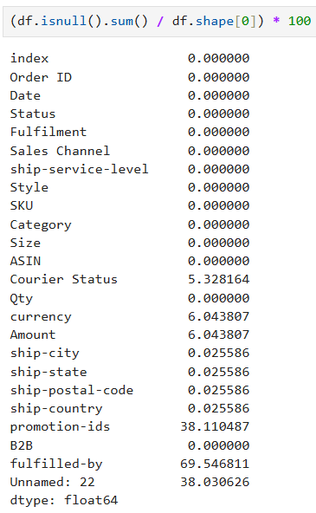
Fig 2: Image indicating percentage of null values
3.1.2. Checking for duplicates and anomalies

After handling the null values, the dataset has been checked for duplicates, duplicates were checked using df[df.duplicated()] and there weren't any significant duplicate entries found. Later it was also checked for anomalies and there were many anomalies found specifically in “ship city” and “ship-state”. “ship-city” wasn’t necessary and it has been dropped but “ship-state” was necessary for the analysis and thus was treated using the “replace” function. “Ship-state” had many anomalies, for example ‘Delhi’ has been written as ‘ DELHI’, ‘new delhi’ etc. and it was all replaced to ‘DELHI’

3.1.3. Detecting outliers
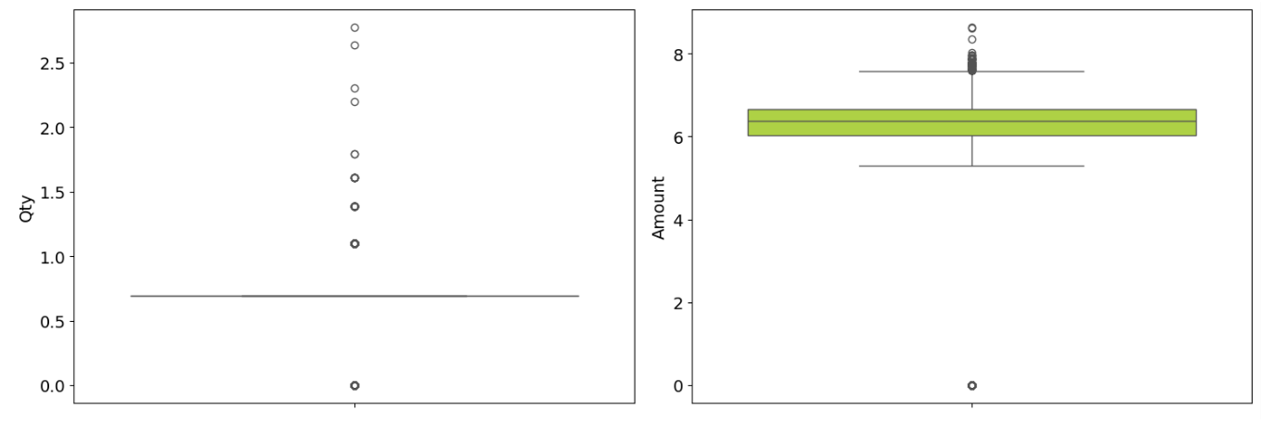

The figure presents two box plots that analyze the distribution of Order Quantity (Qty) and Transaction Amount.The Order Quantity plot shows that most transactions involve a very small number of items, with the median close to one unit. The distribution is highly right-skewed, indicating that bulk purchases are relatively rare. Several outliers appear at higher quantities, suggesting occasional large-volume orders that deviate significantly from typical customer behavior. The Transaction Amount plot exhibits greater variability compared to quantity. While the majority of transactions are clustered within a moderate price range, the upper tail contains numerous high-value outliers. This indicates the presence of infrequent but significant high-value purchases, which may be driven by premium products, bulk orders, or special transactions.
presence of outliers and its treatment:
Outliers are significantly present across numerous numerical columns in the dataset. Options for outlier treatment includes removal of extreme values, data transformation (logarithmic transformation for skewed data like Amount), or utilizing models that are inherently robust to outliers (e.g., tree-based models). Here we are having only two numeric variables (i.e Qty and Amount). We are having edible outliers in the numeric variables. Since Amount is our target variable, we are not applying any scaling or transformation on the numeric variables.
3.1.4 Overall summary of numerical data

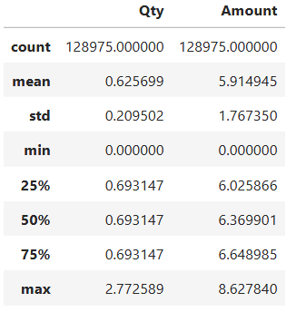

- The dataset contains 128,975 records for both Quantity and Amount.
- Quantity values are mostly consistent, with a median of ~0.69 and a maximum of 2.77, indicating limited variation.
- Amount shows moderate spread, with an average of ~5.91 and values ranging up to 8.63.
- Overall, the data appears stable with few extreme values, suggesting uniform transaction behavior.
3.2) EDA

The exploratory data analysis (EDA) got a very important attention in the overall process. Since, it was at this phase several important understanding has been obtained regarding the data. To make the process a bit elaborate and meaningful, it has been divided into uni-variate, bi-variate and multivariate analysis. This has been done to understand each and every column, their behaviour and contribution to the data. In the univariate phase it was mostly the data distribution, patterns and differences among their categories were observed. In bi-variate phase the behaviour of two different columns with each other and their relation was studied. Multivariate analysis gave an overall view of how all the columns were related. Specifically in this dataset we only had two numerical columns, there weren't many takeaways to observe. A brief explanation along with the visuals have been given below.

3.2.1. Distribution of Sales Amount
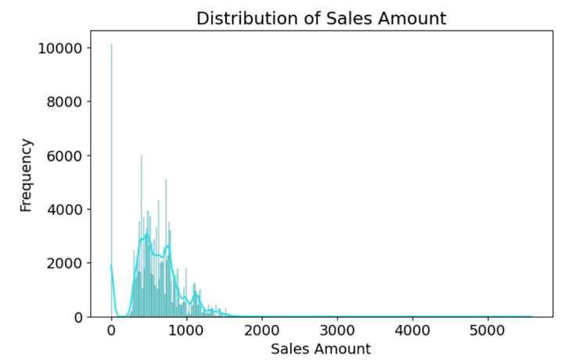
Fig 2: distplot of sales vs frequency
The sales amount distribution is right-skewed, indicating that most orders are of lower value, while a small number of high-value orders contribute significantly to total revenue. This helps identify key revenue-driving transactions.
3.2.2. Distribution of Quantity Sold
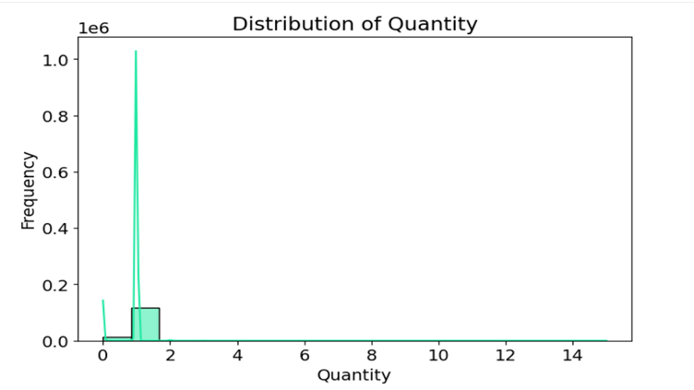
Fig 3: Quantity vs frequency
The quantity distribution shows that most orders contain one or two items, with higher quantities being less frequent. This indicates typical customer purchasing behavior and opportunities for increasing basket size.
3. Quantity vs Sales Amount
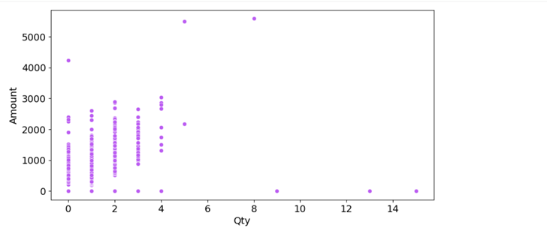
Fig 4: scatterplot of Qty vs sales
A scatter plot of quantity sold vs sales amount reveals a positive relationship: higher quantities generally result in higher revenue. The variability shows the impact of product pricing and category on sales.
3.2.4. Category-wise Sales Amount
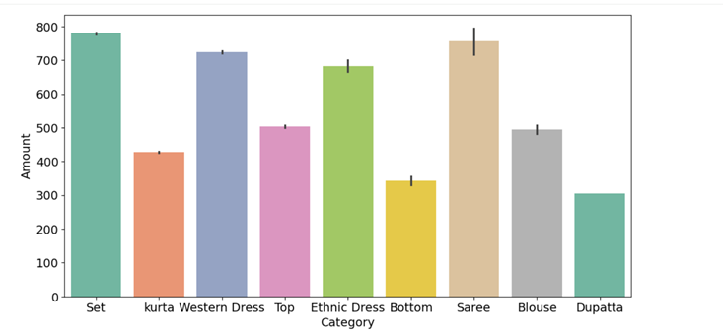
Fig 5: Bar plot of category vs Amount
Sales amount varies across product categories, with some categories consistently generating higher median sales. This highlights category-level demand differences and helps target promotions more effectively.
3.2.5. Category-wise Order Count
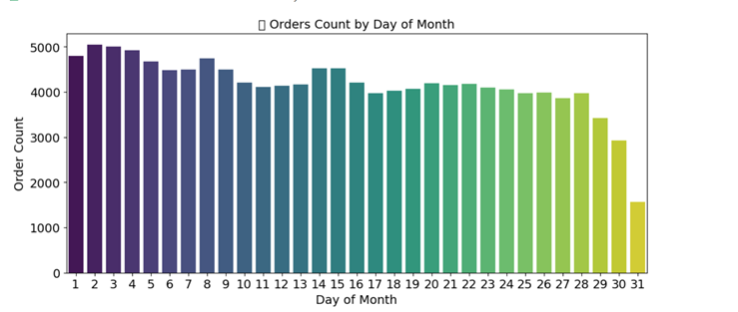
Fig 6: Count plot of days vs order count
Order counts fluctuate across different days of the month, with certain days consistently showing higher activity. This indicates periodic buying behavior possibly linked to salary cycles or promotional timing.

3.2.6. Orders Count by Month
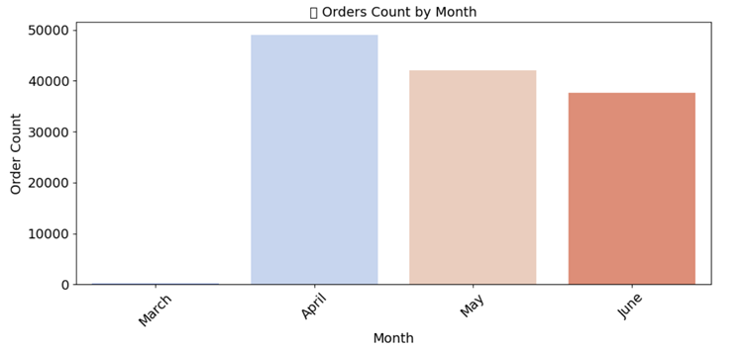
Fig 7: Month vs order count
Monthly order count reveals seasonal patterns and fluctuations in demand. Some months show higher sales volume, which may correlate with promotional campaigns or festive seasons.
3.2.7. Orders Count by Year
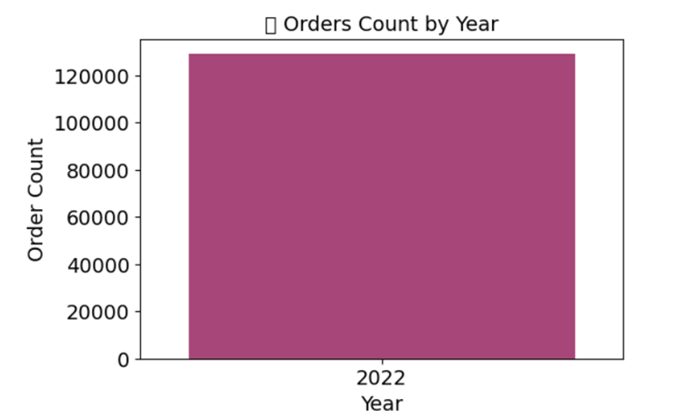
Fig 8: Order count by year
Year-wise analysis shows variation in total order volume across years, helping assess overall business growth and performance trends over times
3.2.8. Daily Orders Trend Over Time
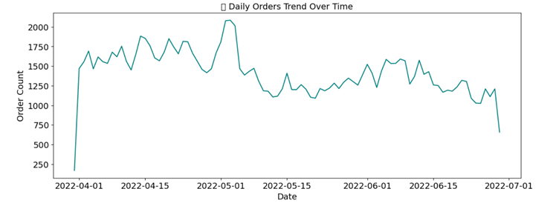
Fig 9: Lineplot showing trend of orders
A line chart of daily orders over time shows short-term trends and overall order growth. Peaks and dips indicate periods of high and low customer activity.
3.2.9. Monthly Orders with Year Comparison
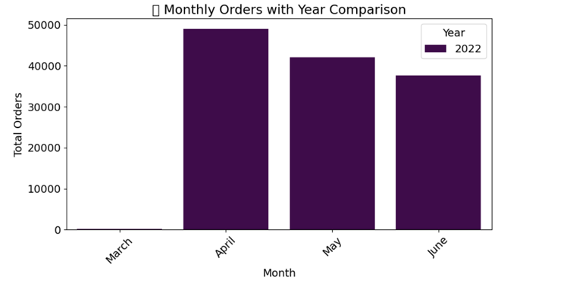
Fig 10: Month vs total orders bar plot
A bar chart comparing monthly orders across years shows trends and improvements over time. It allows tracking performance year-over-year and identifying periods of growth.

3.2.10. Top 8 States by Total Sales
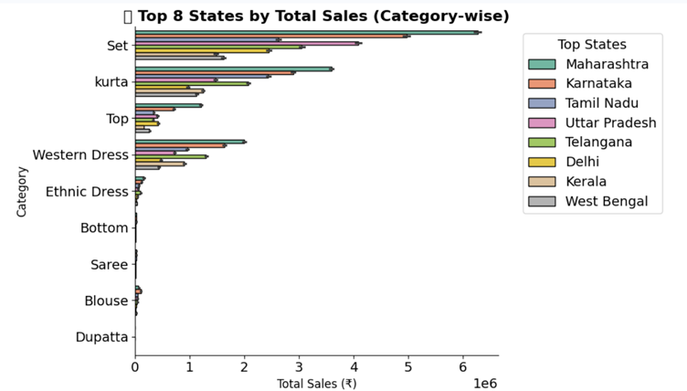
Fig 11: Top total sales
Sales are concentrated in a limited number of states, indicating region-specific demand. These high-performing states represent key markets for focused marketing and logistics optimization.
3.2.11. Shipping status
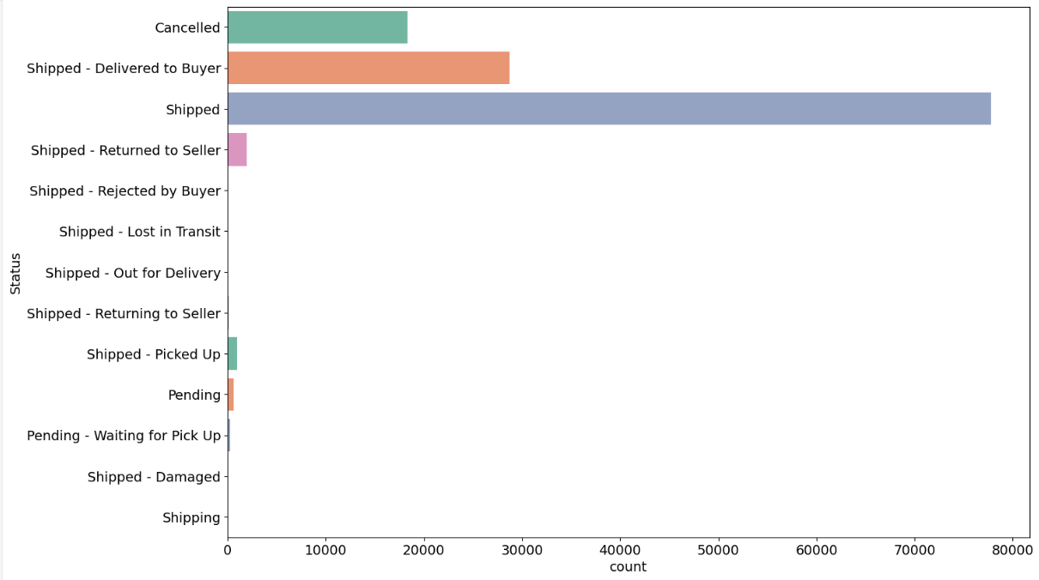
Fig 12: Countplot for shipping status
Over 75,000 orders have been shipped, making it the most frequent status on the chart. The next highest category is shipped and delivered to buyers, accounting for approximately 30,000 orders. Order cancellations rank third in volume, trailing behind the other two statuses.

3.3) STATISTICAL TESTS

3.3.1) Shapiro test

A Shapiro-Wilk test was conducted on the 'Amount' variable to assess its distribution's normality. The significance level for the test was set at 0.05.
- Ho: The data in amount column is normally distributed
- Ha: The data in amount column is not normally distributed
Test Results: The test yielded a p-value of 6.915 times 10^-90 and test statistics of 0.965.
Conclusion: Since the p-value of 6.915 times 10^-90 less than the significance level (0.05), the null hypothesis Ho of the data being normally distributed is rejected. The analysis statistically confirms that the 'Amount' data is not normally distributed. This conclusion is further supported by the visualization , which likely shows a non-bell-shaped curve.

3.3.2) Levene’s Test:
To assess whether the variances of the two numerical columns, 'Amount' and 'Qty' (Quantity), are equal, a Levene's test was performed.
- Ho: Variance among the amount and Qty column is equal among the given data
- Ha: Variance among the amount and Qty column is not equal among the given data

Test Results: The Levene's test yielded a high statistic of 175918.337 and a p-value of 0.0.

Conclusion: Using a standard significance level Sig_val of 0.05. Since the p-value (0.0) is significantly less than the significance level, the null hypothesis Ho is rejected. The statistical evidence strongly indicates that the variance between the 'Amount' column and the 'Qty' column is not equal (i.e., they exhibit heteroscedasticity). This finding suggests that caution may be needed if using statistical methods that assume equal variances (homogeneity of variances) between these two groups.

3.3.3. Pearson r Test:
A Pearson r correlation test was conducted to investigate the linear relationship between the 'Amount' and 'Qty' (Quantity) variables.
- Ho: There is no linear correlation between 'Amount' and 'Quantity'.
- Ha: There is a linear correlation between 'Amount' and 'Quantity'.
Test Results: The test provided the following key results, Correlation Coefficient (statistic): r = 0.391, P-value : 0.0

Conclusion: Using a standard significance level of 0.05, Since the p-value 0.0 is substantially less than the significance level, the null hypothesis Ho is rejected. The analysis confirms that there is a statistically significant linear correlation between 'Amount' and 'Quantity'. The correlation coefficient of approx 0.391 indicates a moderate, positive linear relationship—meaning higher quantities are associated with higher amounts.

3.3.4. Chi-square Test

A Chi-Square Test of Independence was performed to assess whether there is a statistically significant relationship or association between the two categorical variables: 'Category' and 'Size'.

- Ho: The observed and expected frequencies are the same
- Ha: The observed and expected frequencies are not the same
Test Results: The chi- square test was then applied to the observed frequencies, yielding the following results, P-value : 0.0, Chi-Square Statistic : 76548.087
Conclusion: Using a standard significance level of 0.05, Since the p-value is significantly less than the significance level 0.05, the null hypothesis Ho is rejected. The statistical evidence strongly suggests that there is a significant association (dependence) between the 'Category' and 'Size' of the products. In practical terms, the distribution of sizes is not the same across all product categories. For instance, the demand or availability of specific sizes (e.g., 'Free' or 'L') is highly related to the type of product (e.g., a 'Saree' might frequently be 'Free Size', while a 'Bottom' might not).

3.3.5. ANOVA Test
A One-Way Analysis of Variance (ANOVA) test was conducted to determine if there is a statistically significant difference in the mean 'Amount' across the various product 'Category' groups identified in the data (Set, Kurta, Western Dress, Top, Ethnic Dress, Bottom, Saree, Blouse, Dupatta).
- H0: The means of 'Amount' for all product categories are equal.
- H​a: The mean 'Amount' of at least one product category is not equal to the others.
Test Results: The ANOVA test (using stats.f_oneway) compared the 'Amount' samples for the nine distinct categories and yielded the following, F-statistic: 6135.683, P-value (p-value): 0.0
Conclusion: Using a standard significance level (sig_value) of 0.05, Since the p-value (0.0) is substantially less than the significance level, the null hypothesis (H0​) is rejected. The analysis provides strong evidence that the means of the 'Amount' variable are not the same across all product categories. In other words, the average price (or amount) paid for at least one product category is statistically different from the others. Further post-hoc testing would be required to identify exactly which pairs of categories have significantly different mean amounts.

3.3.5.1 Post-Hoc Analysis

The rejection of the null hypothesis in the ANOVA test confirms that a statistically significant difference exists in the mean 'Amount' across the product categories. The post-hoc analysis confirms that significant variations in transaction 'Amount' exist across the different product categories. While most categories have distinct average amounts, a few pairs (e.g., Blouse and Top, Bottom and Dupatta) share similar average 'Amounts'. This information is crucial for understanding the pricing or sales patterns associated with specific product types
o statistical significance of variables:
Assessing the statistical significance of variables involves determining if the observed relationship between a feature and the target variable is likely due to chance or if it represents a true underlying association. This would typically be performed after selecting a model or during specific feature selection stages using statistical tests (t-tests for individual coefficients in linear regression, ANOVA for impact of categorical variables on target, or feature importance scores from tree-based models).
We carried out the above tests and all of the mentioned tests were rejecting Ho.

o class imbalance and its treatment:
Class imbalance can be a concern in this analysis, especially if the problem is reframed as a classification or regression task (e.g., predicting whether a promotion significantly increases sales or not). In the dataset, a large number of transactions have no or few promotions, while only a small portion of orders are associated with multiple or high-impact promotions. This creates an imbalance between “non-promotional” and “promotional” transactions.
If we model the relationship between promotional activity and sales amount, this imbalance can bias the model towards predicting low or no promotional impact. To address this, several approaches can be applied:
- Resampling Techniques:
  - Oversampling transactions influenced by promotions to balance the dataset.
  - Undersampling transactions without promotions to reduce dominance of the majority class.
      - Synthetic Data Generation:
        - Use algorithms such as SMOTE (Synthetic Minority Oversampling Technique) to generate synthetic samples of underrepresented promotional cases, ensuring the model learns balanced patterns.
      - Alternative Modeling Strategies:
        - Build a two-stage model, where the first stage predicts whether a promotion affects sales (binary classification)and the second stage estimates the sales uplift for those affected transactions (regression).
We could see that the distribution of the sales amount is right skewed.
Test Results: The test yielded

3.4) FEATURE ENGINEERING
Feature engineering has played a huge part in building this model. Even Though the dataset had most of the necessary features, identifying a target column directly was challenging. So, a new column has to be derived from the “amount” column by aggregating the amount summed over a week as total amount per week and merged with the original dataset to create a new column called “amount_y” which was later assigned as the target column.
Another notable manipulation happened on the “promotion-ids” column. The “promotion-ids” column had huge sentences like texts defining different types of promotions applied on each product. It was observed that most of them are the same type except for the serial number or unique identifier for that individual coupon. Thus, the group decided to group the coupons based on their categories like free shipping coupons, finance promotions, etc. This has been done to reduce the complexity involved in building the model and also to avoid any misleading that could possibly happen when training the model.
3.4.1) Feature selection
Since, the target has to be featured based on the timeline, the date column was split into weeks, months and years to get an understanding of the data distribution across segmented time periods. However this data gave an idea of the current scenario, its variations based on previous data was still unknown. So, this was further manipulated into lead and lag time frames where each frame showed how the sales varied with respect to its previous weeks. This feature was found to be very useful to study the behaviour of sales across time periods.
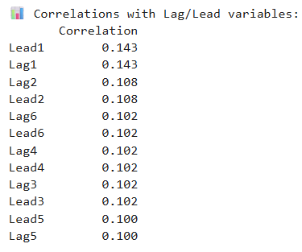
Fig : Image showing lead / lag variables correlation
Furthermore, the data was not normal as it will be in practical scenarios. The skewed data was found to be a cause for reduced metrics in the model performance, thus it has been decided to perform a transformation.
3.4.2) Transformation
The “amount” columns were found to be highly right skewed due to the presence of outliers. Since outliers were agreed to be a part of the study, the data was causing a negative impact on the model’s performance. So, a “log 1-p” transformation technique was used on the numerical columns which adjusted the data closer to normal and a significant raise in the scores were noticed. To further normalize the data, Yeo-Johnson power transformer was also used.
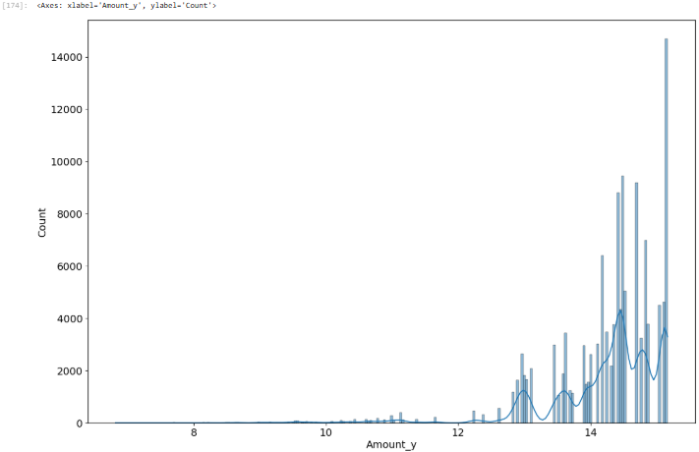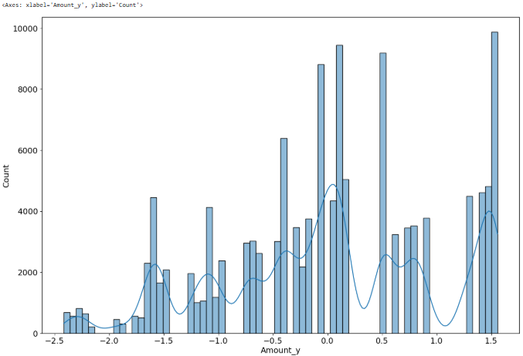
Fig: Images showing target distribution before and after transformation
3.5) ENCODING
In the notebook, categorical features such as status, fulfilment type, category, size, ship-state, and promotion IDs were prepared for modeling by handling missing values with meaningful labels instead of removing records. The date column was transformed into a proper datetime format and further engineered into day, month, year, and month name features to capture temporal patterns in sales. Boolean features like B2B were retained in their original form since they are already suitable for machine learning models. Numerical variables such as quantity and amount were cleaned by imputing missing values and examining their distributions and outliers using statistical summaries and boxplots. The analysis revealed right-skewness in the numerical features, indicating the need for scaling or transformation before applying regression models. Feature scaling was considered important to ensure that quantity and amount contribute proportionally during model training. Overall, these encoding, scaling, and transformation steps converted raw transactional data into structured, model-ready features.
3.6) MODEL BUILDING

Finally after performing an array of data preparation procedures, the building of machine learning algorithms took place. Like it was discussed earlier, there is a column to guide the mode and the decided target column was a numeric column and this necessitates the use of supervised learning - regression based algorithms to support the study. It beginned with fitting a base linear regression model which is an OLS model and metrics like r2 score, RMSE, adjusted r2 values were observed.

3.6.1) Linear Regression

The OLS model has been chosen as the base and first model. This model has been chosen because of the model’s simplicity in computation and easy to interpret nature. The OLS model gave the idea of how the data is and how much improvement it needs. The initial scores were very less and seemed that the model was performing very poorly.

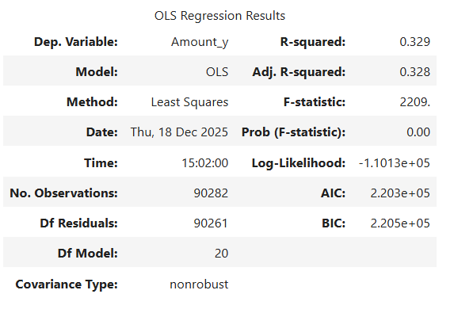
Fig : Results from 1st OLS regression model

It can be inferred from the above model that the r-squared value is very low. This means the model is under performing and needs more tuning. To fine tune the model several strategies like transforming the data, using generalization techniques were deployed. These techniques resulted in a significant raise in the overall r-squared and produced significantly less errors.

3.6.2) Non-Linear models

While using the linear models were offering a consistent raise in the performance, the non-linear models were also providing concrete results. The following non-linear models were used:

- Decision tree
- Random forest
- Gradient boosting
- XG boosting
- Ada boost

These models out performed the linear models, but some models were very much prone to overfitting. So, it was necessary to hyper tune these models to obtain the right metrics and build them to be useful. Most of the hyper was done using grid search CV and validated using k-fold cross validation.

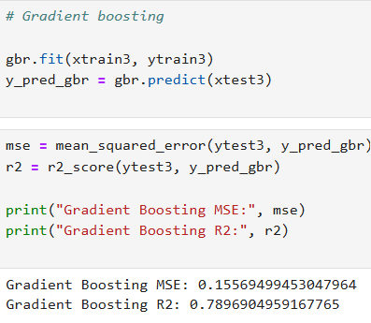
Fig : Gradient boosting model

- MODEL EVALUATION

There were several models built with each one of them giving different metrics, finding the model that can be used and implemented became a bit challenging. However, the models have been evaluated using k-fold validation technique. Through this technique, the model variance has been optimized and the model has become more generalized.

The overall assessed models have been presented as a table below:

MODELS | R2 Score
Linear Regression | 0.32
Random Forest | 0.85
Decision tree | 0.80
Gradient boosting | 0.79
OLS | 0.51

After a number of trial and error, these were the scores that were obtained. Among this, the non-linear algorithms seem to offer a better result than the linear algorithms. This could be due to the non compliant nature of the data with respect to the ideal assumptions of linear regression. Among the models found, Random forest has been found to have the better r2 score and less MSE, thus random forest has been chosen to be the final model.

4.1) BENCHMARKING

The models were benchmarked against the base OLS model which had a very low r-squared value of 0.51 after applying transformation. This indicated that the model’s performance was not upto the mark and it hasn’t been training well on the training data. Following this other linear algorithm techniques like ridge, lasso and linear regression using sklearn were performed and none of the models seem to out perform the base model. They had relatively lower r-squared values and high RMSE.

It was followed by using non-linear models like decision tree, random forest and boosting techniques. After performing hyperparameter tuning, random forest and gradient boosting showed a significantly high performance. They achieved a r-squared value of 0.85 and 0.79 respectively. Both of them performed the base model as well as every other model that were tested earlier. Also, the RMSE values have been found to be very low indicating that the model elevated from underfitting and performing well. Among the two, random forest has been chosen to be the final model

- IMPLICATIONS

The findings of this study provide valuable business and analytical insights for an online clothing retail company operating in a highly competitive e-commerce environment. The analysis confirms that promotional strategies do have a measurable impact on sales, but their effectiveness varies across product categories, regions, and time periods. Certain categories and states consistently generate higher revenue, indicating that promotions should be targeted rather than uniformly applied across all products and locations. The strong performance of non-linear models such as Random Forest highlights the presence of complex, non-linear relationships between promotions, quantity sold, and sales amount, which traditional linear models fail to capture adequately.

It can be observed that from a business perspective, this implies that data-driven decision-making using advanced machine learning models can significantly improve demand forecasting, promotion planning, and inventory management. By leveraging these insights, the organization can optimize promotional budgets, improve customer engagement, and maximize revenue without relying solely on aggressive discounting strategies. For instance, more focus can be given on least sold product, identify the reason for low sales and tailor any specific promotion that could boost their demand. This confirmed that promotional strategies have to be more dynamic rather than being static. Some scenarios of dynamic strategies could include adapting promotions based on seasonality, focus on different products rather than the same one, try to offer promotion for most of the seasons, etc.

- LIMITATIONS

Despite the strong analytical framework and model performance, the study has certain limitations that should be acknowledged.
- First, the dataset is restricted to a single e-commerce platform and a specific product segment (clothing), which may limit the generalizability of the findings to other industries or platforms.
- Second, the target variable was feature-engineered using aggregated weekly sales, which may smooth out short-term promotional effects such as flash sales or limited-time offers.
- Third, although outliers were intentionally retained to reflect real-world scenarios, they may still influence model predictions under extreme conditions. Additionally, external factors such as competitor pricing, customer demographics, marketing spend, and macroeconomic conditions were not included in the dataset, even though they can significantly impact sales behavior.
- Lastly, while Random Forest delivered strong predictive performance, it sacrifices interpretability compared to linear models, making it harder to explain individual predictions to non-technical stakeholders.

- CLOSING REFLECTIONS

This project successfully demonstrates how machine learning techniques can be applied to real-world e-commerce data to derive actionable business insights. Starting from raw transactional data, the systematic approach of data preprocessing, feature engineering, transformation, encoding, and model evaluation ensured the development of a robust and reliable predictive framework. The comparison between linear and non-linear models clearly showed that complex retail data often violates traditional modeling assumptions, making advanced ensemble methods more suitable. Beyond model performance, the project emphasized the importance of understanding data behavior, business context, and statistical validity before drawing conclusions.

Overall, this capstone project reinforces the value of combining domain knowledge with data science methodologies to support strategic decision-making in e-commerce and lays a strong foundation for further enhancements such as real-time promotion optimization and customer-level personalization.

- REFERENCES

- E. Dritsas and M. Trigka, "Machine Learning in E-Commerce: Trends, Applications, and Future Challenges," in IEEE Access, vol. 13, pp. 99048-99067, 2025, doi: 10.1109/ACCESS.2025.3572865.
- Policarpo, L. M., da Silveira, D. E., da Rosa Righi, R., Stoffel, R. A., da Costa, C. A., Barbosa, J. L. V., ... & Arcot, T. (2021). Machine learning through the lens of e-commerce initiatives: An up-to-date systematic literature review. Computer Science Review, 41, 100414.
- Mishra, R. K., Mishra, D., & Agarwal, R. (2024). APPLICATIONS OF DATA SCIENCE IN E-COMMERCE. Journal of Science Research International (JSRI) ISSN, 2456, 6365.
- https://www.42signals.com/blog/ecommerce-data-analytics-for-brands/
- Sharma, Rahul & Sharma, Pankaj & Mishra, Shilpi & Vashistha, Sudhanshu. (2020). Data Science in E-commerce. International Journal of Engineering Science Technology And Research. 5. 80-84.

